# Customer Onboarding Process

## Problem Statement

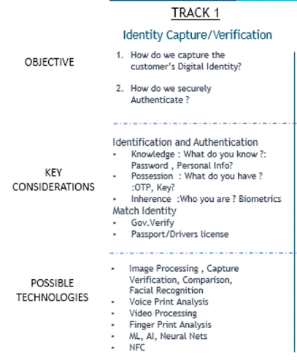

## Solution Outline:

Modes: Offline & Online

Platforms: Mobile (Flutter and Dart) and Web (Angular4)

Users Roles:

**1) New User:**

(Business Function)

Register Me:

-- Notifying and then Capture: (Client System)

-- Face

-- Voice Print (With name information)

-- Biometric

-- Filtering and Data Preparation: (Client System)

-- Noise filtering

-- Feature extractions and Map preparation (Keep Client/Server)

-- Data modelling (Data Definition)

-- Data Storage, linking and Indexing: (Server Side)

-- Identity Management infra using cloud storage providers like Amazon, Google or Microsoft

-- Open Block chain providers.

-- Status notification to user (Client System)

**2) Registered User**

(Business Function)

**Log Me in**:

-- Notifying and then Capture: (Client System) Function of 3 Identifiers

-- Face

-- Voice Print

-- Biometric

-- Filtering and Data Preparation: (Client System)

-- Noise filtering

-- Feature extractions and Map preparation (Keep Client/Server)

-- Data modelling

-- Data retrieval and Authentication: (Server Side)

-- Identity Management infra using cloud storage providers like Amazon, Google or Microsoft

-- Open Block chain providers.

-- Status notification to user (Client System)

(Business Function)

**Update My Details**:

-- Notifying and then Capture: (Client System)

-- Face

-- Voice Print

-- Biometric

-- Filtering and Data Preparation: (Client System)

-- Noise filtering

-- Feature extractions and Map preparation (Keep Client/Server)

-- Data modelling

-- Data Storage, linking and Indexing: (Server Side)

-- Identity Management infra using cloud storage providers like Amazon, Google or Microsoft

-- Open Block chain providers.

-- Status notification to user (Client System)

**3) Bank Employee**

<To discuss and develop later>

## Questions

## 

1. What minimal information is required for registering a user?
   1. Face
   2. Name
   3. Age?
2. How would we want to interface brokers into the system?
   1. **Approach 1**: Broker logs into the app and then visits loan applicant to add them using the app interface. (using the hardware broker carries and not manually)
   2. **Approach 2**: No broker is involved and Mobile app\Web Interface is passed onto the end user which is used to register a new user or modify existing ones.

**Problem statement**: